Installed minikube and docker in ubuntu

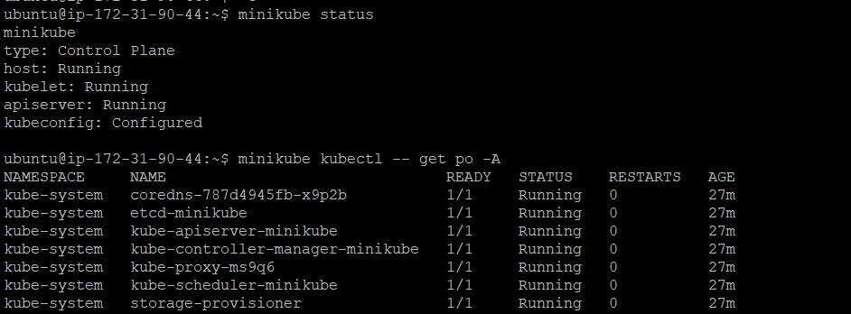

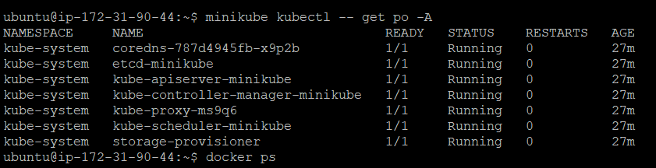

Pulled the Jenkins images from docker hub

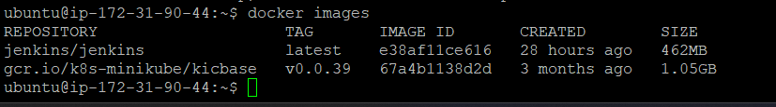

Ran the container using below command and mounted to /opt

docker run -u 0 -itd --name jenkins-container -p 8080:8080 -p 50000:50000 -v /opt:/var/jenkins_home e38af11ce616



Logs:

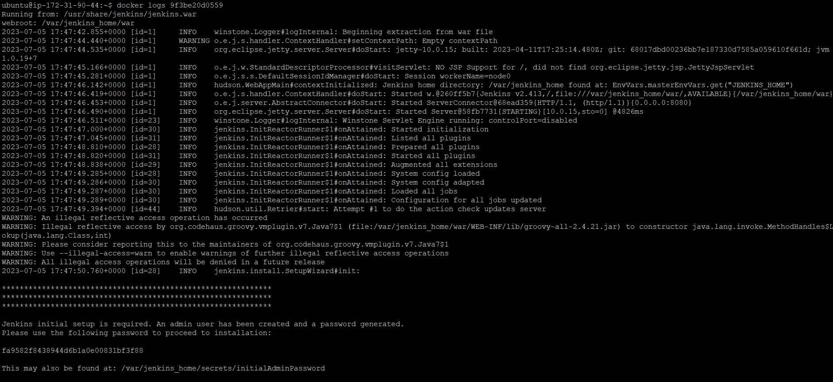

Console output:

